About the Organisation

Summary

Name | Lyra Learning Pty Ltd (trading as “Lyra”)
Age | 1 year — incorporated in New South Wales in 2025
Industry | Public Education
Sector | Information Technology
Size | 34 full-time equivalent staff (30–40 band) — a medium-sized business under the Australian Bureau of Statistics employment-size ranges, which class businesses with 20–199 employees as medium (Australian Bureau of Statistics, 2023)
Geographical Presence | National. Headquartered in Sydney, New South Wales, serving public universities in NSW, Victoria and Queensland. All data is hosted onshore in the AWS Sydney region. No international operations at present.

Introduction
Lyra Learning Pty Ltd is a Sydney-based educational technology company, incorporated in New South Wales in 2025, that builds a curriculum-grounded artificial intelligence study platform for universities. Lyra connects to a unit of study’s approved readings, notes and lecture recordings, and uses large language model APIs to let students interrogate, summarise and revise that material, with every answer citing its source.
Our mission is to make a student’s own course materials genuinely navigable, so that learning is limited by curiosity rather than reading speed. Our vision is that every Australian public university offers a governed study companion rather than unmanaged consumer tools. Our business objectives for FY2027 are eight university-wide licences, ninety per cent renewal, and gross margin above seventy per cent.
Culturally we are deliberately small and cross-functional: engineers, learning designers and former academics sit in the same squads, product claims are settled by evaluation data rather than enthusiasm, and privacy is an engineering constraint, not a policy afterthought.

About the Industry and Sector
Public education in Australia is a large and closely regulated industry: around forty universities, most of them public, taught about 1.68 million students in 2024, around 35% of them from overseas (Department of Education, 2025), under the Higher Education Standards Framework (Threshold Standards) 2021 (Cth) administered by TEQSA. The information technology sector serving it — educational technology vendors, learning platforms and integration layers — is mature in administration but immature in artificial intelligence.
Competition falls into three groups. Learning management incumbents such as Canvas, Moodle, Blackboard and D2L own the system of record and are adding generative features, but those are generic, roadmap-bound and rarely grounded in a specific unit’s material. Consumer AI tools such as NotebookLM, ChatGPT and Perplexity are capable but institutionally invisible: a university cannot see, govern, or defend their output at an academic integrity hearing. Australian specialists such as Studiosity, Cadmus and Turnitin solve adjacent problems — study support and assessment integrity — not curriculum-grounded retrieval.
The market gap sits between these groups. No vendor currently offers a NotebookLM-class experience confined to institution-approved content that cites its sources, keeps data onshore, launches inside the existing learning management system, and gives academics visibility over use. As a one-year-old company of thirty-four people, carrying no legacy platform, we can build that narrow product faster than an incumbent can retrofit it.

Current Technology Landscape
Australian public universities run a recognisable and largely standardised stack. A learning management system — Canvas, Moodle or Blackboard — is the system of record for teaching; a student information system such as PeopleSoft or TechnologyOne handles enrolment and results; Zoom and Echo360 capture lectures; Turnitin screens submissions; and identity is federated through the Australian Access Federation using Shibboleth, Okta or Microsoft Entra ID. Integration is standardised on 1EdTech specifications, principally Learning Tools Interoperability (LTI) 1.3 and LTI Advantage (1EdTech Consortium, 2019), with Caliper Analytics and xAPI carrying learning telemetry. The CAUDIT reference architecture and the Australian Universities Procurement Network shape how new systems are evaluated and bought.
Infrastructure has largely moved to public cloud, overwhelmingly the AWS Sydney region and Azure Australia East, and data residency is treated as close to non-negotiable. Around that stack sits a substantial compliance envelope: the Privacy Act 1988 (Cth) and the Australian Privacy Principles (Office of the Australian Information Commissioner, 2022); the Privacy and Personal Information Protection Act 1998 (NSW) for state institutions; the Disability Discrimination Act 1992 (Cth), with WCAG 2.2 Level AA as the practical accessibility benchmark (World Wide Web Consortium, 2023); and TEQSA guidance on generative artificial intelligence and assessment integrity (Lodge et al., 2023).
The artificial intelligence layer itself is new and moving quickly. Frontier model APIs from Anthropic, OpenAI and Google have made retrieval-augmented generation (Lewis et al., 2020) practical without any in-house model training; embeddings and vector stores such as pgvector are inexpensive; and inference cost per token continues to fall. What has not kept pace is institutional readiness. Since 2023 the sector’s response to generative artificial intelligence has been predominantly defensive — detection tooling, assessment redesign and policy — rather than the provisioning of a governed alternative (Lodge et al., 2023).
The resulting landscape has strong administrative systems, credible cloud foundations and clear interoperability standards, but a conspicuous absence of sanctioned artificial intelligence tooling at the exact point where students actually study. That absence is the space our platform occupies.

Common IT Challenges
Several challenges recur across university information technology. The first is a fragmented content estate: readings, slides, recordings and library reserve material live in different systems with inconsistent metadata, so no single retrievable corpus exists for a unit of study. The second is integration debt — years of point-to-point connections, inconsistent LTI implementations and thinly staffed integration teams — which makes every new tool expensive to onboard. The third is privacy and data sovereignty: student records are sensitive, yet where an institution provides no sanctioned tool, students use consumer services anyway and material leaves institutional control entirely unobserved. The fourth is trust: ungrounded models hallucinate and offer no provenance (Ji et al., 2023), giving academics sound reason to resist them. The fifth is procurement and funding — risk-averse, cyclical, and gated by lengthy security and accessibility assessments that small vendors routinely fail. The sixth is capability: universities compete poorly against industry for artificial intelligence engineering talent. The seventh is equity — accessibility obligations, large international and English-as-an-additional-language cohorts, and students who cannot afford premium consumer subscriptions.
Lyra is designed against precisely this list. The platform ingests only material an academic has approved for a given unit, producing the governed corpus that does not otherwise exist. It launches through LTI 1.3 inside the existing learning management system, making deployment a configuration task rather than an integration project. Retrieval is grounded by default: every answer cites its source document and page, and the model is instructed to decline rather than speculate where the corpus does not support an answer. All processing and storage remain in the AWS Sydney region, and no student data is used to train models. An educator dashboard surfaces where a cohort is struggling, turning a student tool into a teaching signal. Finally, a pre-completed security, privacy and accessibility conformance pack compresses the procurement cycle that would otherwise exclude a company of our size.

Business Model Canvas
The Business Model Canvas (Osterwalder & Pigneur, 2010; Strategyzer AG, n.d.) below summarises how Lyra creates, delivers and captures value. Figure 1 presents the completed canvas, and a full-page copy is reproduced in Appendix A. Each of the nine building blocks is explained in turn beneath the figure.
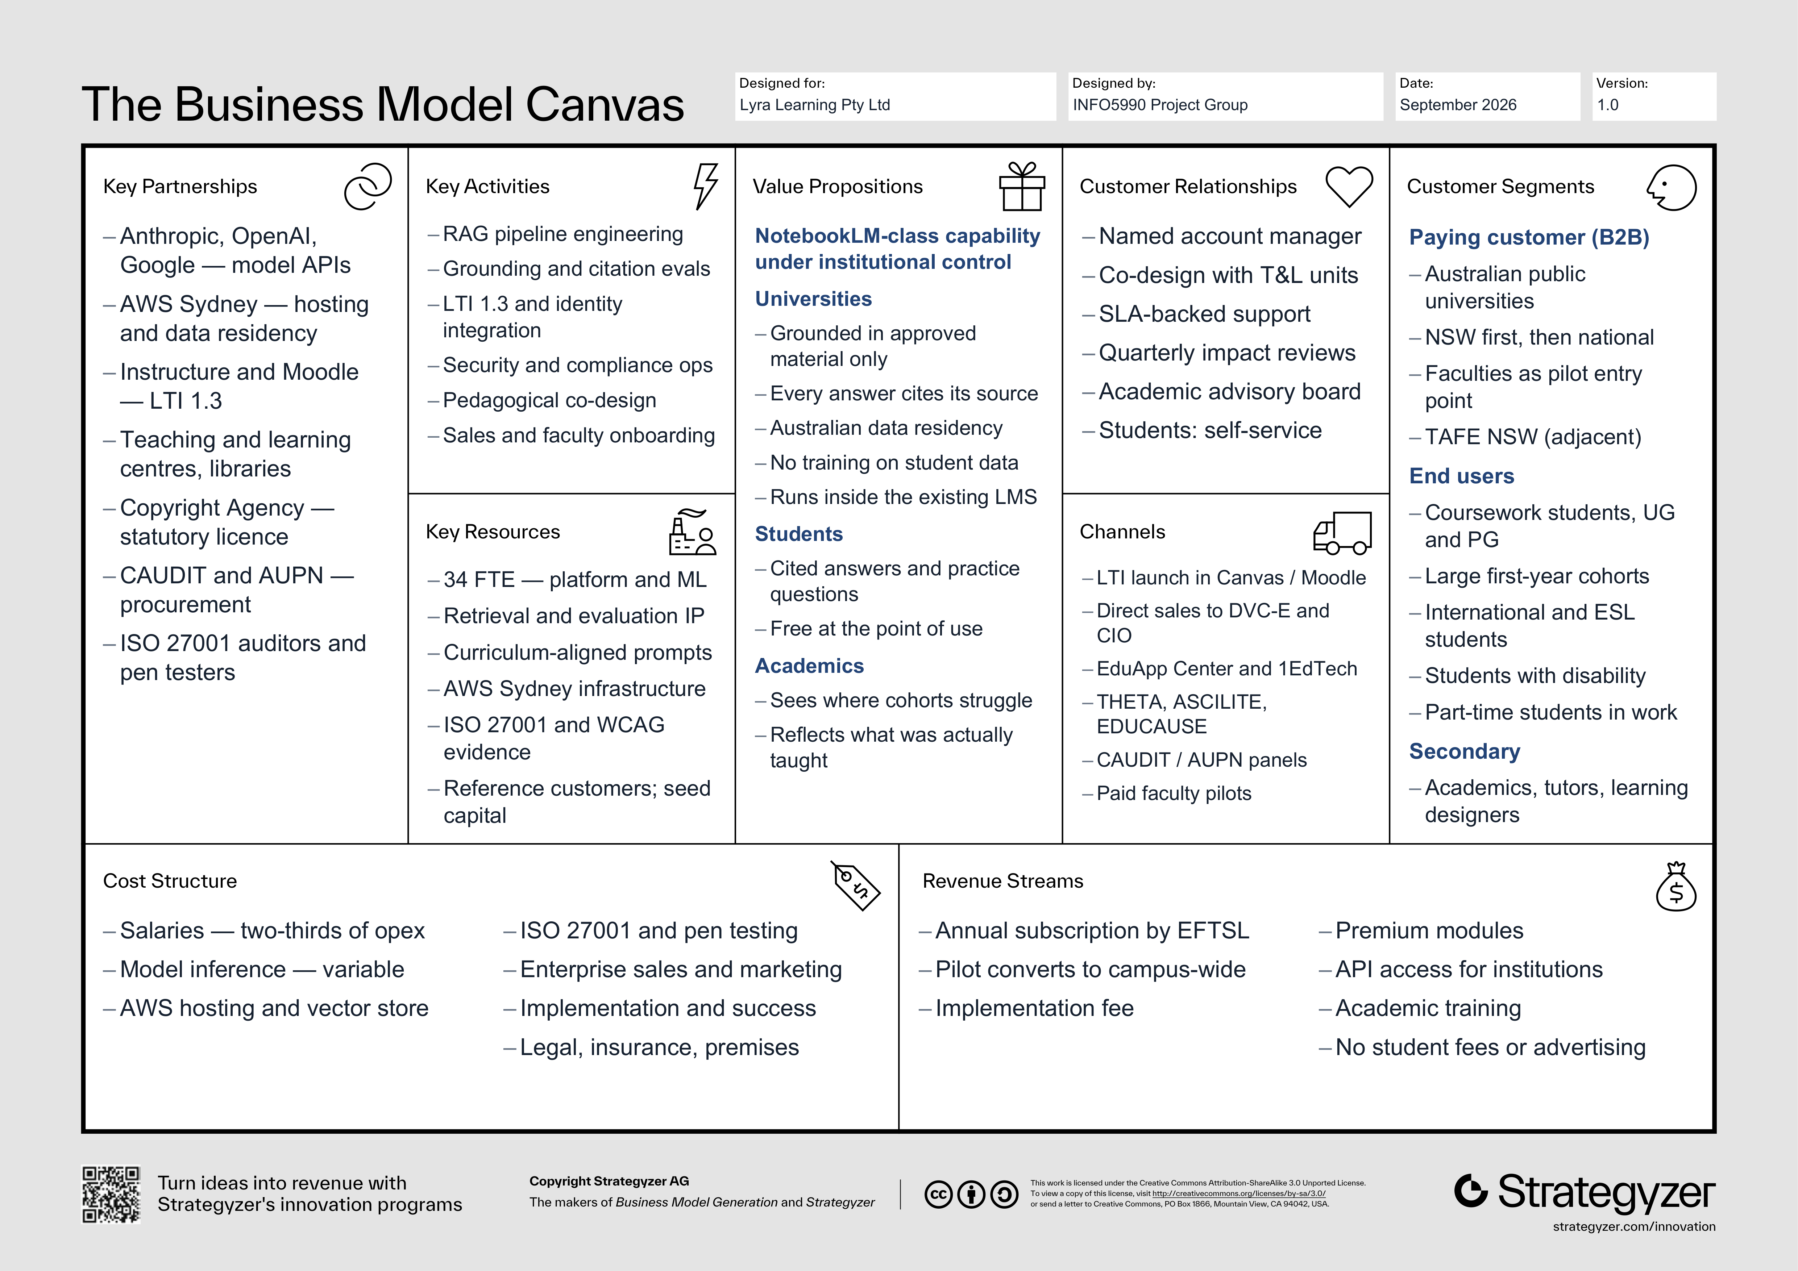
Figure 1. Business Model Canvas — Lyra Learning Pty Ltd (reproduced full page in Appendix A). Canvas template © Strategyzer AG, used under CC BY-SA 3.0.

Key Partnerships
Our partnership model reflects a decision to buy capability rather than build it. Frontier model providers — Anthropic, OpenAI and Google — supply inference under commercial agreements, keeping model training out of our cost base but creating a dependency we manage through a multi-provider abstraction layer. Amazon Web Services provides Sydney-region hosting and underwrites our data residency. Instructure and Moodle matter as platform partners, because 1EdTech LTI certification is what makes us installable. Teaching and learning centres and libraries are co-design partners rather than merely customers. Beyond these sit the Copyright Agency for statutory licensing, CAUDIT and AUPN for procurement reach, and external auditors for ISO 27001 certification.

Key Activities
The activities consuming most of our capacity are engineering the retrieval-augmented generation pipeline — ingestion, chunking, embedding, retrieval quality and citation fidelity — and the evaluation work that keeps it honest, since grounding is our central commercial claim and must therefore be measured rather than asserted. Alongside this sits integration engineering against LTI 1.3 and each institution’s identity provider, plus continuous security, privacy and compliance operations. Pedagogical co-design converts unit learning outcomes into prompts and question templates. Commercially, we run long enterprise sales cycles, faculty-by-faculty onboarding, and customer success reporting that demonstrates measurable impact, because renewal here depends on evidence rather than enthusiasm.

Key Resources
Our principal resource is people: thirty-four staff weighted towards platform and machine learning engineering, supported by learning designers, customer success and a small compliance function. Our intellectual property is not a model but the layer around it — retrieval and ranking logic, the evaluation harness that scores grounding and citation accuracy, and a curriculum-aligned prompt library built with academic partners. Technically we depend on AWS Sydney infrastructure, a vector store, and committed model-API capacity. Commercially, our most valuable assets are completed security and accessibility assessments, ISO 27001 certification, named university reference customers with usage evidence, and the seed capital funding our runway to sustainable revenue.

Customer Relationships
Because we sell to institutions but serve students, we maintain two different relationships. With the institution the model is high-touch and long-term: a named account manager and solutions engineer per university, co-design workshops with teaching and learning units, SLA-backed support, and quarterly business reviews reporting usage and learning impact against agreed measures. An academic advisory board gives senior staff genuine influence over the roadmap, and a cross-client community of practice lets universities learn from one another. With students the relationship is intentionally self-service — in-product guidance, a help centre and feedback channels — because a study tool that requires training will not be used.

Channels
Our strongest channel is structural rather than promotional: once a licence is in place, Lyra launches from inside Canvas or Moodle through LTI 1.3, so the university’s own learning management system distributes us to every enrolled student with no separate download, account or login. Acquisition, however, is direct enterprise sales into the Deputy Vice-Chancellor (Education), Chief Information Officer and Director of Educational Innovation. We supplement this with listings on the Instructure EduApp Center and 1EdTech directories, presence at THETA, ASCILITE and EDUCAUSE Australasia, and CAUDIT and AUPN preferred-supplier arrangements. Paid faculty pilots are our principal entry mechanism, and academic word of mouth our most efficient source of qualified interest.

Customer Segments
We operate a business-to-business model in which payer and user differ. Our paying segment is Australian public universities, initially in New South Wales and then nationally, with individual faculties — typically large first-year cohorts in business, engineering or health — as the pilot entry point. TAFE NSW and dual-sector providers are an adjacent segment we expect to address once the university product matures. Our end users are coursework students, undergraduate and postgraduate, and the platform delivers disproportionate value to international and English-as-an-additional-language students, students with disability, and part-time students balancing study against work. Academics, tutors and learning designers form a secondary user group via the educator dashboard.

Cost Structure
Our cost structure is value-driven and predominantly fixed. Salaries are by far the largest line at roughly two-thirds of operating expenditure, reflecting Sydney engineering rates and an intentionally senior team. The significant variable component is model inference and embedding spend, which scales directly with student usage; managing that cost through caching, retrieval efficiency and model routing is central to protecting gross margin as we grow, and is the principal unit-economics risk in our plan. Remaining costs are AWS Sydney hosting and vector storage; compliance and certification including ISO 27001 and penetration testing; enterprise sales and marketing against long procurement cycles; implementation and customer success; and legal, insurance and premises.

Revenue Streams
Revenue comes almost entirely from recurring institutional subscriptions. Universities license Lyra annually, priced in bands against equivalent full-time student load (EFTSL), which aligns our price with the value an institution receives while keeping it predictable for budgeting. We deliberately follow a land-and-expand pattern in which a paid faculty pilot converts into a campus-wide licence. Secondary streams are a one-off implementation fee; premium modules such as the analytics dashboard, multilingual support and assessment-aligned question generation; API access for institutional systems; and paid professional development for academic staff. Multi-year contracts carry CPI escalation. We take no student payments and no advertising revenue — a deliberate equity and trust decision.

Value Proposition
Lyra offers NotebookLM-class capability under institutional control. For universities that means a governed study layer confined to material academics have approved, with every answer citing its source, all data resident in Australia, no student data used for model training, and deployment inside the existing learning management system rather than another system to adopt — replacing ungoverned shadow use with something auditable. For students it means immediate, cited answers, summaries and practice questions drawn from their own unit materials, available continuously and free at the point of use. For academics it means visibility into where a cohort is struggling and confidence that answers reflect what was actually taught.

References
1EdTech Consortium. (2019). Learning Tools Interoperability core specification (Version 1.3). https://www.imsglobal.org/spec/lti/v1p3
Australian Bureau of Statistics. (2023). Counts of Australian businesses, including entries and exits. https://www.abs.gov.au/statistics/economy/business-indicators/counts-australian-businesses-including-entries-and-exits
Department of Education. (2025). Key findings from the 2024 higher education student statistics. Australian Government. https://www.education.gov.au/higher-education-statistics/student-data/selected-higher-education-statistics-2024-student-data/key-findings-2024-higher-education-student-statistics
Disability Discrimination Act 1992 (Cth). https://www.legislation.gov.au/C2004A04426/latest
Higher Education Standards Framework (Threshold Standards) 2021 (Cth). https://www.legislation.gov.au/F2021L00488/latest
Ji, Z., Lee, N., Frieske, R., Yu, T., Su, D., Xu, Y., Ishii, E., Bang, Y. J., Madotto, A., & Fung, P. (2023). Survey of hallucination in natural language generation. ACM Computing Surveys, 55(12), 1–38. https://doi.org/10.1145/3571730
Lewis, P., Perez, E., Piktus, A., Petroni, F., Karpukhin, V., Goyal, N., Küttler, H., Lewis, M., Yih, W., Rocktäschel, T., Riedel, S., & Kiela, D. (2020). Retrieval-augmented generation for knowledge-intensive NLP tasks. Advances in Neural Information Processing Systems, 33, 9459–9474.
Lodge, J. M., Howard, S., Bearman, M., Dawson, P., & Associates. (2023). Assessment reform for the age of artificial intelligence. Tertiary Education Quality and Standards Agency. https://www.teqsa.gov.au/guides-resources/resources/corporate-publications/assessment-reform-age-artificial-intelligence
Office of the Australian Information Commissioner. (2022). Australian Privacy Principles guidelines. https://www.oaic.gov.au/privacy/australian-privacy-principles/australian-privacy-principles-guidelines
Osterwalder, A., & Pigneur, Y. (2010). Business model generation: A handbook for visionaries, game changers, and challengers. John Wiley & Sons.
Privacy Act 1988 (Cth). https://www.legislation.gov.au/C2004A03712/latest
Privacy and Personal Information Protection Act 1998 (NSW). https://legislation.nsw.gov.au/view/html/inforce/current/act-1998-133
Strategyzer AG. (n.d.). The business model canvas [Template]. https://www.strategyzer.com/library/the-business-model-canvas
World Wide Web Consortium. (2023). Web content accessibility guidelines (WCAG) 2.2. https://www.w3.org/TR/WCAG22/
Appendix A — Business Model Canvas
Business Model Canvas — Lyra Learning Pty Ltd. Canvas template © Strategyzer AG, used under CC BY-SA 3.0.

